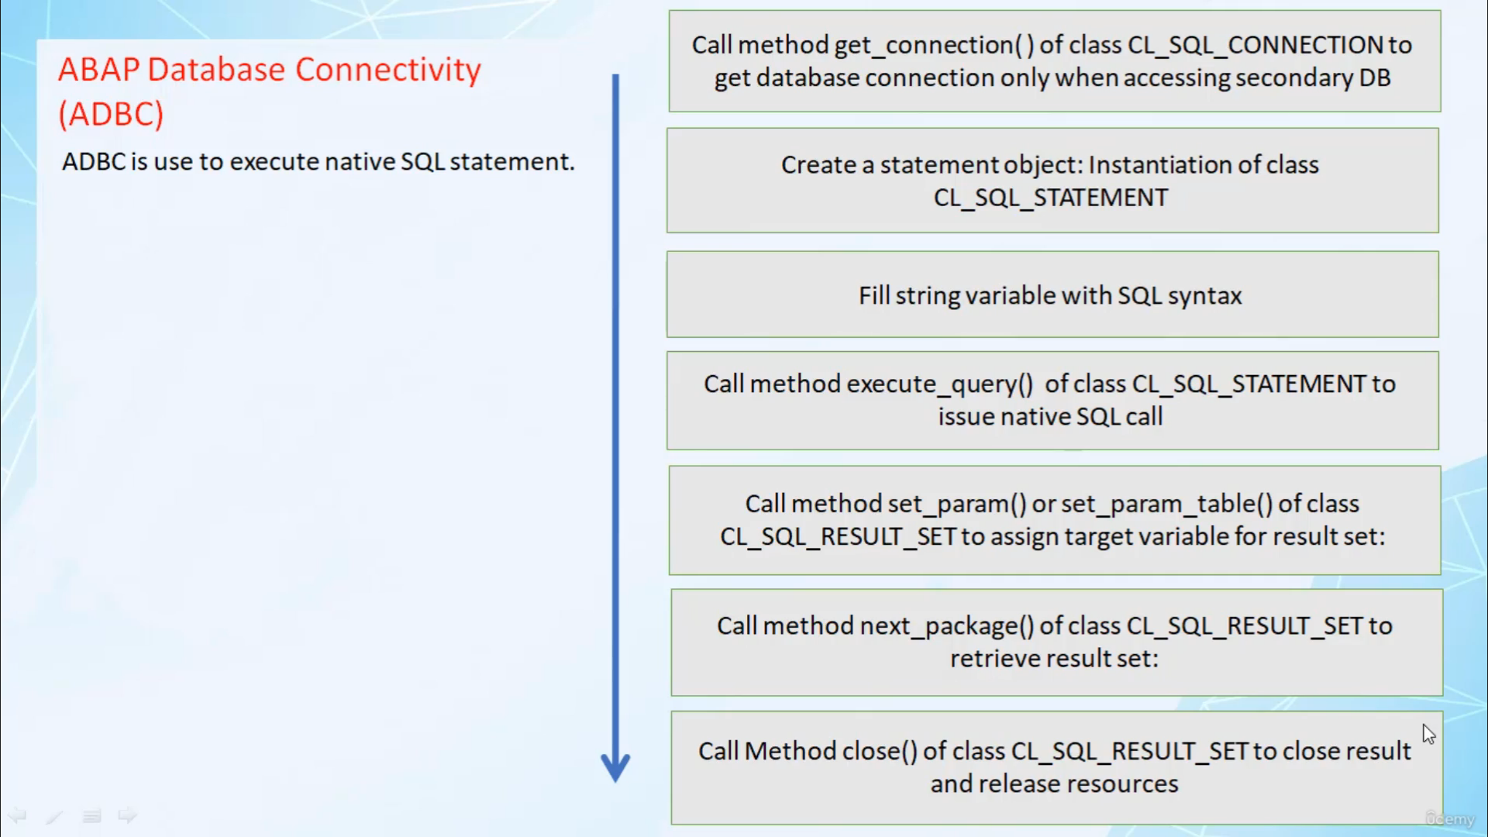

Hi, welcome back.

In this video, I will tell you about Adebisi ABAB database connectivity.

So let's start.

ABC is used to execute the statement I simply recommend A.B.C. for to is calling about instead of older

squill statement

APC's flexible, its support, object oriented programming, error handling and various list, it is

not difficult to use as only two or three main classes are relevant.

In most cases, the often used classes are classed as equal connection to establish connection with

database class as a statement to execute a school query class a school ResultSet to retrieve data from

a school query.

When using they do a school, you should be aware of certain things such as the syntax of nikto is clustering

is not cheap by ABAB Compiler.

Hence it's better to use exception class C as an exception to analyze message redenbach database if

they do as Western contains any error.

An optimal buffer is bypassed, hence this can makes them to a school goal slower than opening statements.

You have to explicitly use Glenfield in their condition, joint condition and so on.

When using a C, you have to follow the logical sequence to issue a skill created in this logical sequence.

For Stubbies, you are to call me and get connection of class, plus a school connection to get databased

connection.

You are to perform this step only when accessing secondary database.

And step number two, you are to create the object of class class a squill statement.

In step three, you are to string variables with escalating decks.

Step for your to call method execute query of class as a statement to issue only to a call.

Then and next step you are to call method set parameter or set parameter table of class as ResultSet

to assign target variable for resulting in the next step you are to call method next package of class

Esequiel ResultSet to retrieve ResultSet.

And in the last day you are to call method close of class at school ResultSet to close result and release

resources.

So it is pretty straightforward to use A.B.C..

Just you have to follow these steps.

Now, let's create one apropo program, and in that program, we will try to use a database connectivity

like.